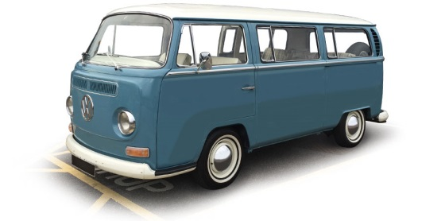

Historic Registration Day
24th June 9am-1pm
Linde Reserve Carpark- Stepney (enter carpark via Stepney St.) Don’t forget to bring: Log Book Car registration Papers Club Membership renewal
$2 Sausage Sizzle Available
