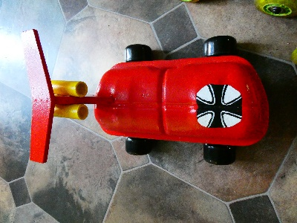  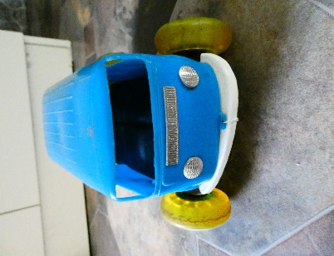

Tappet Cover Racing

Sunday August 25th

The Gums

Shakespeare Ave Tranmere

10.30am

Tea, coffee, soft drink &

B.B.Q lunch provided

You will need to provide your own Rocker Cover Racer.

Dimensions are as follows:

1. Air Cooled VW rocker cover
2. 4 wheels/non-metallic only
3. Weight: 3.5kg
4. Width: 20cm
5. Length: 30cm

Please text Kevin: 0411632523 to confirm attendance by

August 23rd for catering. Thanks.

