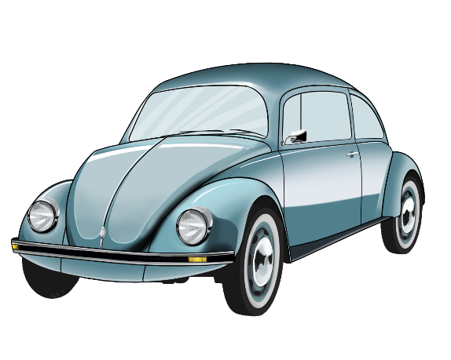

The cruise will finish at Xtraction Coffee Connoisseures

4/20 Canterbury Dr.

Salisbury Heights

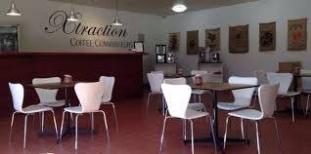 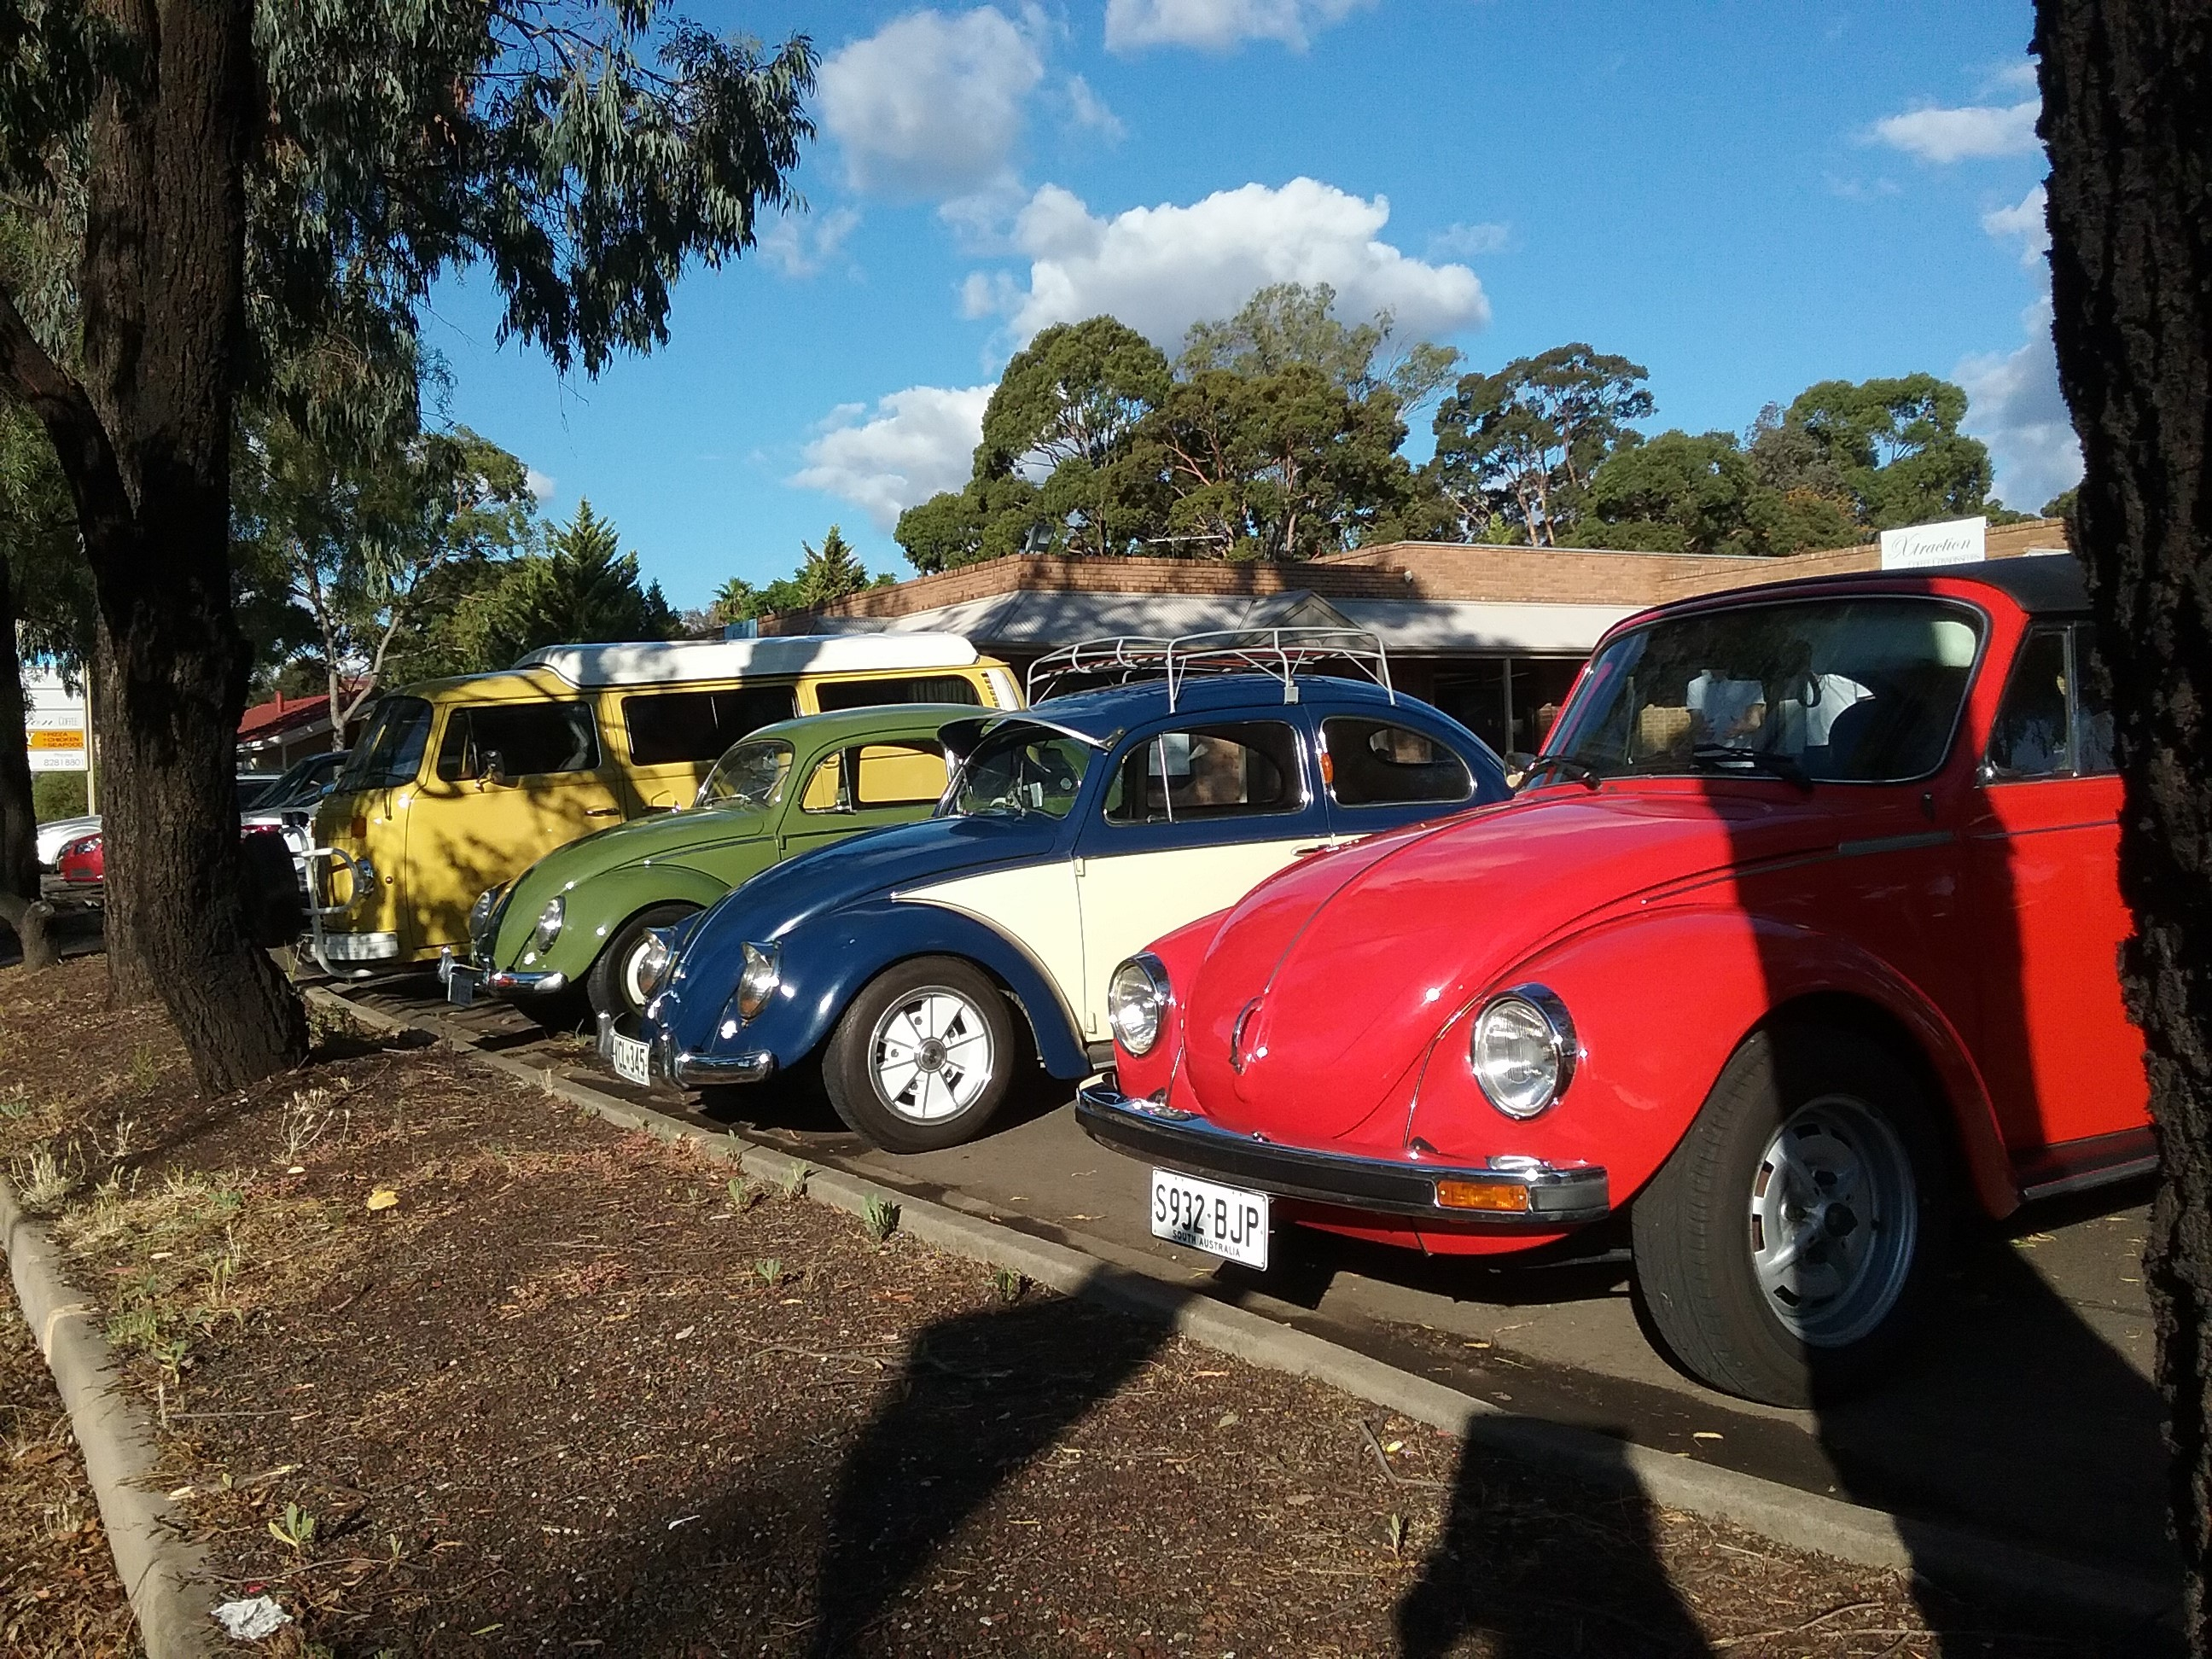

Sunday 21st July 2019

Meet at Linde Reserve

Nelson Rd. Stepney

at 2:30

we aim to have most participants on their way by 3pm.

OBSERVATION CRUISE