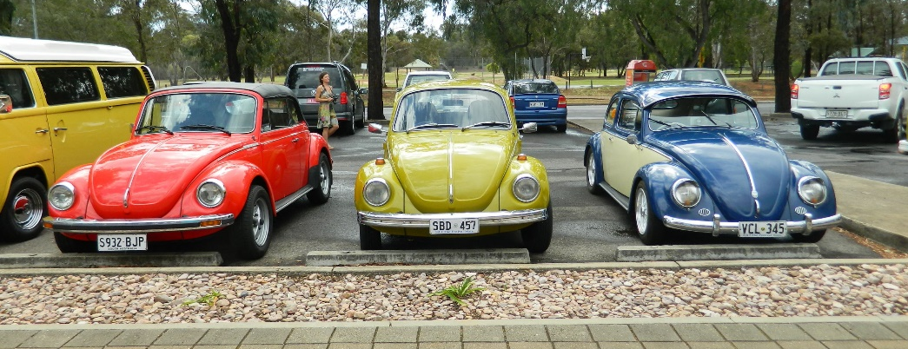

Pizza In The Park
Saturday 23rd February
Linde Reserve, Stepney
5.30pm
Park in the Stepney St. carpark at the rear of the park.
$5.00 per person for pizza and soft drinks
Please bring your own chairs
For those in the north we will be meeting at Office Works carpark , Main North Rd Parafield at 4.30 for a cruise to the park. For those not cruising meet at Linde Reserve at approx. 5.30 pm. There will be a short general meeting in the park at this time due to the closure of the German Club.

