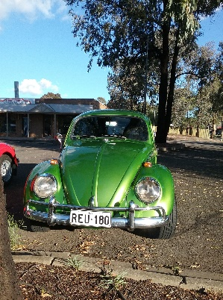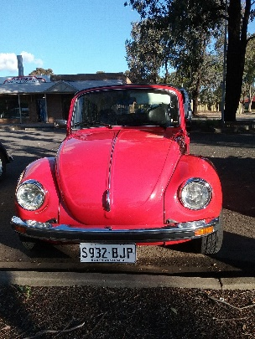

Day of the Volkswagen 2019

Sunday 31st March

Civic Park Modbury

Opposite TTP

9.00am

• Volkswagens

• Show and Shine

• Music

• Food

