

Xmas fun and VW themed games at Terry’s

Meet at Hungry Jacks Parafield at 8:30am or

Bunnings car park Seaford at 10:00am

We will then drive to Terry’s property in Currency Creek for a BBQ lunch, with some fun and games and swim (bring you bathers and a towel).

Please bring one small unisex VW themed gift per person up to the value of $15 for a Kris Kringle. If you are bringing children please provide one gift per child clearly labeled with their name.

 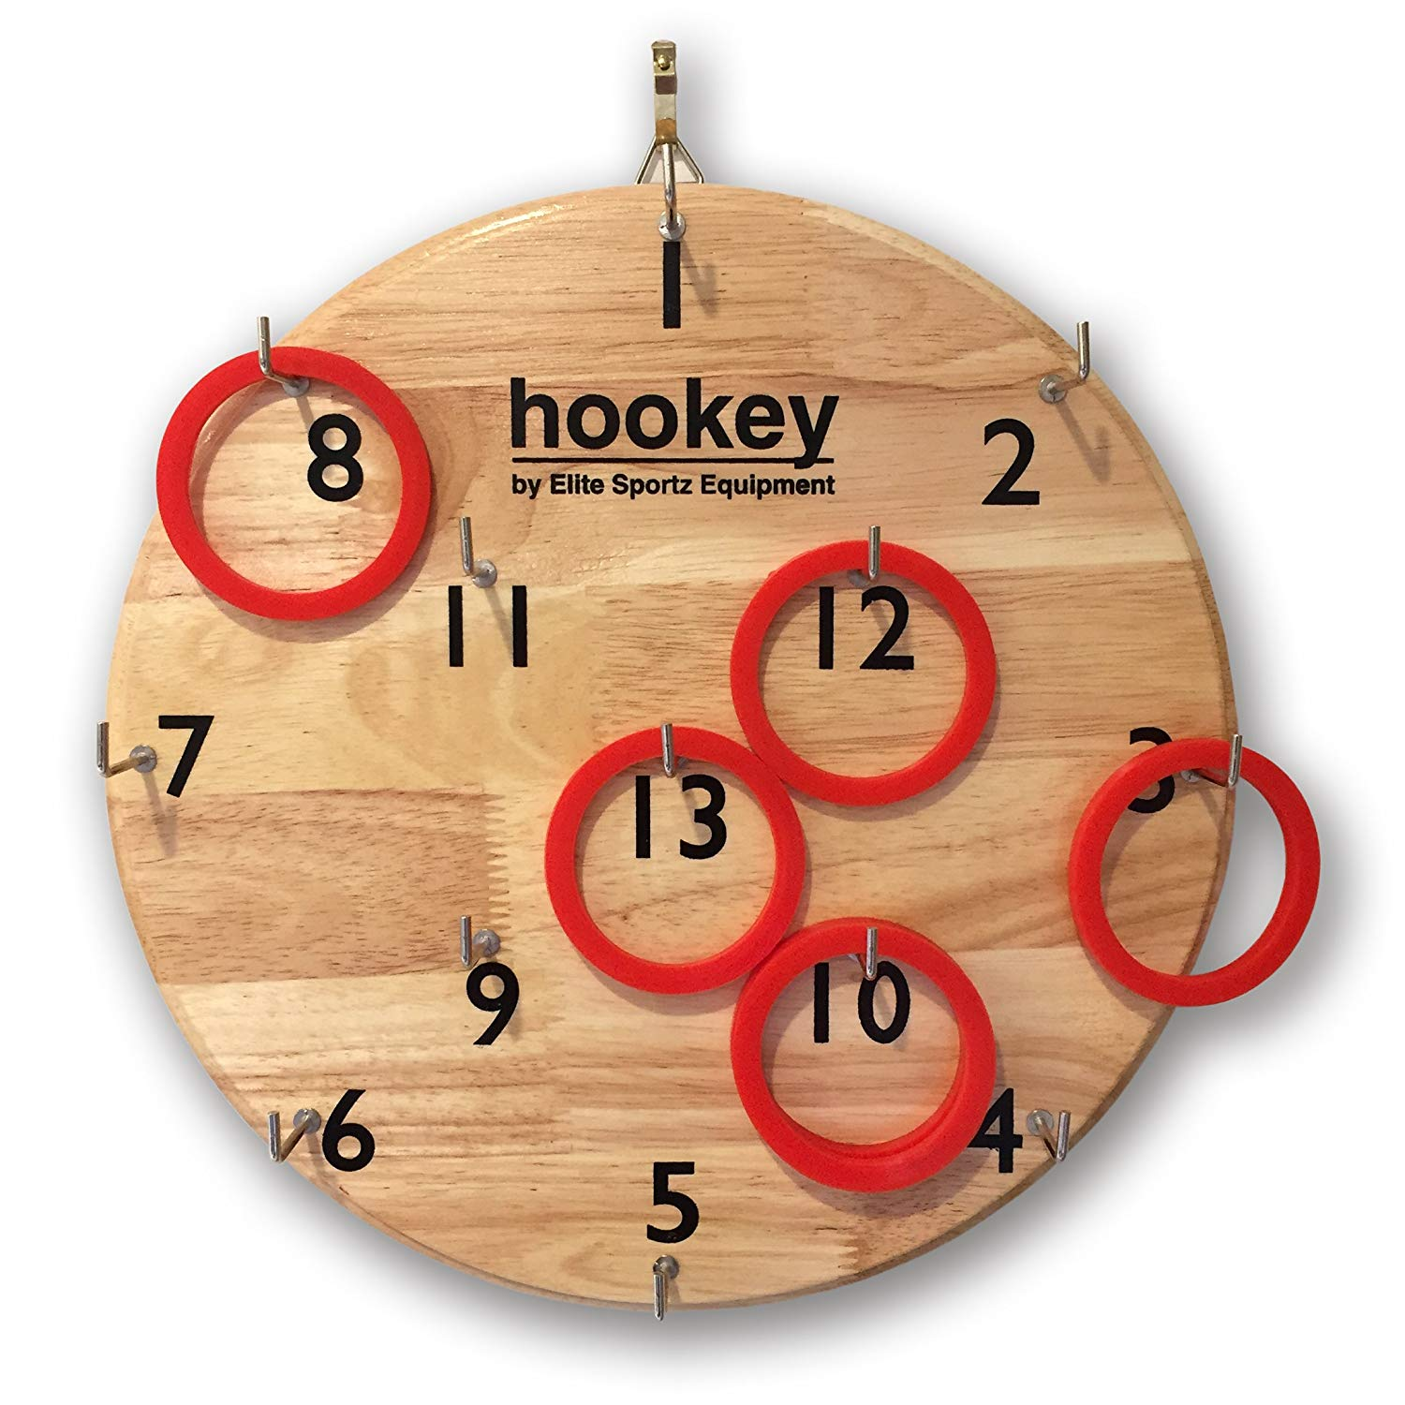 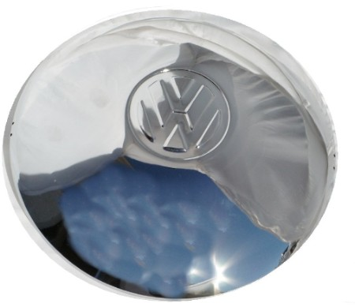

Quoits Hookey Hub Cap toss

And more…..

Please text Kevin on 0411632523 or leave a message on 82505489 to confirm numbers for catering purposes.



December 16th